实验三:Runge现象的产生和克服

程序1：lagrange多项式插值
syms f x p dp lx L;
f=1/(1+25*x^2);
N=input('请输入插值节点数N=');
xx=-1:2/N:1;
p=1; L=0;
ff=zeros(1,length(xx));
for i=1:(N+1)
x=xx(i);
ff(i)=eval(f);
syms x;
p=p*(x-xx(i));
end
dp=diff(p);
for j=1:(N+1)
x=xx(j);
k=eval(dp);
syms x;
lx=p/((x-xx(j))*k);
L=L+lx*ff(j);
end
aa=[-0.96:0.1:-0.06,0,0.06:0.1:0.96];
for i=1:length(aa)
x=aa(i);
S(i)=eval(L);
fff(i)=eval(f);
end
e=0;
for i=1:length(aa)
e=e+(S(i)-fff(i))^2;
end
e=sqrt(e/(20*21));
fprintf('插值偏差为e=%.6f\n',e)
ezplot(f,[-1,1])
hold on
ezplot(L,[-1,1])
hold on
plot(xx,ff,'*')
hold on
plot(aa,S,'o')
hold off

程序2：分段线性插值
syms f x p lx;
f=1/(1+25*x^2);
N=input('请输入插值节点数N=');
xx=-1:2/N:1;
p=1; L=0;
ff=zeros(1,length(xx));
for i=1:(N+1)
x=xx(i);
ff(i)=eval(f);
end
syms x
for i=1:N
for j=1:(N+1)
if j==i
lx(i,j)=(x-xx(i+1))/(xx(i)-xx(i+1));
else if j==i+1
lx(i,j)=(x-xx(i))/(xx(i+1)-xx(i));
else
lx(i,j)=0;
end
end
end
end
p=lx*ff';
aa=[-0.96:0.1:-0.06,0,0.06:0.1:0.96];
for i=1:length(aa)
x=aa(i);
for j=1:N+1
if x<xx(j)
break
end
end
S(i)=eval(p(j-1));
fff(i)=eval(f);
end
e=0;
for i=1:length(aa)
e=e+(S(i)-fff(i))^2;
end
e=sqrt(e/(20*21));
fprintf('插值偏差为e=%.6f\n',e)
ezplot(f,[-1,1])
hold on
xxx=(-1:0.01:1);
for i=1:length(xxx)
x=xxx(i);
for j=1:N+1
if x<xx(j)
break
end
end
SS(i)=eval(p(j-1));
end
plot(xxx,SS,'r')
hold on
plot(xx,ff,'*')
hold on
plot(aa,S,'o')
hold off

程序3：三转角插值法
syms f x df s s1 s2 s3 s4;
f=1/(1+25*x^2);
df=diff(f);
N=input('请输入插值节点数N=');
h=2/N;
xx=-1:2/N:1;
p=1; L=0;
ff=zeros(1,length(xx));
for i=1:(N+1)
x=xx(i);
ff(i)=eval(f);
dff(i)=eval(df);
end
syms x
for i=1:N
s1=(x-xx(i+1))^2*(h+2*(x-xx(i)))*ff(i)/h^3;
s2=(x-xx(i))^3*(h+2*(xx(i+1)-x))*ff(i+1)/h^3;
s3=(x-xx(i+1))^2*(x-xx(i))*dff(i)/h^2;
s4=(x-xx(i))^2*(x-xx(i+1))*dff(i+1)/h^2;
s(i)=s1+s2+s3+s4;
end
aa=[-0.96:0.1:-0.06,0,0.06:0.1:0.96];
for i=1:length(aa)
x=aa(i);
for j=1:N+1
if x<xx(j)
break
end
end
S(i)=eval(s(j-1));
fff(i)=eval(f);
end
e=0;
for i=1:length(aa)
e=e+(S(i)-fff(i))^2;
end
e=sqrt(e/(20*21));
fprintf('插值偏差为e=%.6f\n',e)
ezplot(f,[-1,1])
hold on
xxx=(-1:0.01:1);
for i=1:length(xxx)
x=xxx(i);
for j=1:N+1
if x<xx(j)
break
end
end
SS(i)=eval(s(j-1));
end
plot(xxx,SS,'r')
hold on
plot(xx,ff,'*')
hold on
plot(aa,S,'o')
hold off

程序4：三弯矩插值法：
syms f x ddf s;
f=1/(1+25*x^2);
ddf=diff(diff(f));
N=input('请输入插值节点数N=');
h=2/N;
xx=-1:2/N:1;
p=1; L=0;
ff=zeros(1,length(xx));
for i=1:(N+1)
x=xx(i);
ff(i)=eval(f);
ddff(i)=eval(ddf);
end
syms x
for i=1:N
A=(ff(i+1)-ff(i))/h-h*(ddff(i+1)-ddff(i))/6;
B=ff(i)-h^2*ddff(i)/6;
s(i)=(xx(i+1)-x)^3*ddff(i)/(6*h)+(x-xx(i))^3*ddff(i+1)/(6*h)+A*(x-xx(i))+B;
end
aa=[-0.96:0.1:-0.06,0,0.06:0.1:0.96];
for i=1:length(aa)
x=aa(i);
for j=1:N+1
if x<xx(j)
break
end
end
S(i)=eval(s(j-1));
fff(i)=eval(f);
end
e=0;
for i=1:length(aa)
e=e+(S(i)-fff(i))^2;
end
e=sqrt(e/(20*21));
fprintf('插值偏差为e=%.6f\n',e)
ezplot(f,[-1,1])
hold on
xxx=(-1:0.01:1);
for i=1:length(xxx)
x=xxx(i);
for j=1:N+1
if x<xx(j)
break
end
end
SS(i)=eval(s(j-1));
end
plot(xxx,SS,'r')
hold on
plot(xx,ff,'*')
hold on
plot(aa,S,'o')
hold off

图1：观察Runge现象
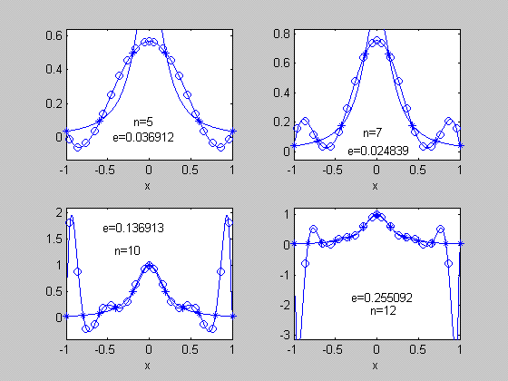

%哈工大资源分享站 QQ2842305604

图2：分段线性插值
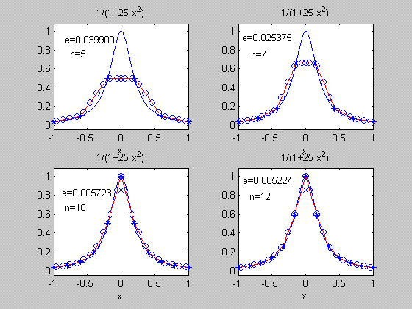

图3：三转角插值：
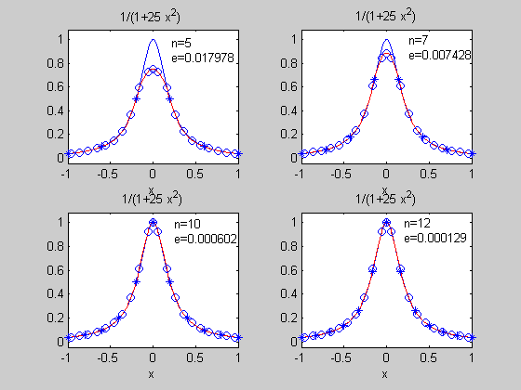
图4：三弯矩插值：
